Chapter 4 Exercises
  - For the waveforms of sinusoidal v(t) and i(t) in figure P4-1, write their time expressions in sine form.
Solution
  - Given the sinusoidal voltage across two nodes a and b as
- Find its amplitude, phase, period and frequency.
- Find v_{ab}(0) and v_{ab}(0.01), and indicate actual voltage polarity of v_{ab} at t =0 and t =0.01s.
- write v_{ba}(t) in sine form.
- Draw the waveform of v_{ab}(t).
Solution
- V_{m}=311V，θ=，T=0.02s，f=50Hz
- , Node ‘a’ is actual positive and node ‘b’ is negative
, Node ‘a’ is actual negative and node ‘b’ is positive
(3)
(4) The waveform of v_{ab} is shown in Figure P4-2.
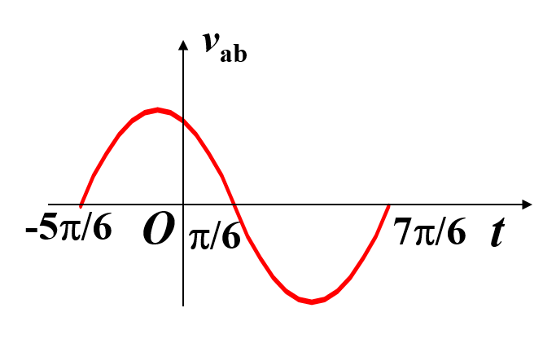
Figure P4-2
  - Two sinusoids v and i are of the same frequency f=50Hz, and V_{m}=100V, I_{m}=2A, and v leads i by T/6.
- Calculate the phase difference between v and i in radians.
- Use v as phase reference, write v and i in sine form.
- Use i as phase reference, write v and i in sine form.
Solution
(1)
(2)
(3)

  - Find phasors for following sinusoids. Draw a phasor diagram and compare their phase relationship.
Solution
There is phase difference between any two of. The phasor diagram is shown in Figure P4-4.
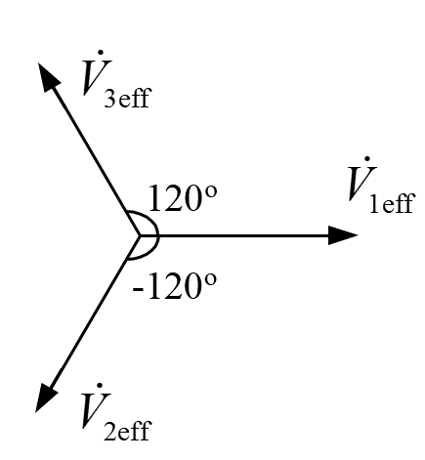
Figure P4-4
  - Given angular frequency ω=10 rad/s, find the sinusoids corresponding to each of the following phasors, and calculate and using phasors.
(1) (2)
(3) (4)
Solution
(1)
(2)
(3)
(4)
  - Use phasor diagram to find the sums of sinusoids of the following.
- Find for
- Find and for and
- If,
and ,find .
Solution
  - Given a phasor and angular frequency ω, find a sinusoid v₂(t) that leads v₁(t) by and has an amplitude of 10V.
Solution
,
  - A voltage is applied to a 10-mH inductor. Find the steady-state current flowing through the inductor for the following frequencies
- f=465kHz.
- f=2kHz.
Solution
  - Find the equivalent impedance Z for the circuit in figure P4-9. Give both rectangular and polar forms.
Solution
  - Find the equivalent impedance Z for the circuit of figure P4-10.
Solution
  - A voltage source is applied to a linear passive two-terminal circuit and causes a steady-state current of .
- Determine the input impedance of the circuit.
- Find steady-state current if the applied voltage becomes .
Solution
(1) Under passive convention
(2)

  - If the two circuits in figure P4-12(a) and (b) are equivalent, find the relationships between r_{c}, x_{c} and G_{c,} B_{c} .
Solution
For (a)
For (b)
Let two networks be equivalent, get
or

  - The circuit of figure P4-13 works in sinusoidal steady state. Given ω =5krad/s, calculate the value of C such that the input impedance Z of the circuit is purely resistive, and find Z.
Solution
Let imaginary part be zero, get
So
  - In figure P4-14,
- Calculate the value of C such that v and i_{S} are in phase.
- Use virtual instruments and AC frequency sweep of EWB simulation to verify the result.
Solution
(1)
When , v and i_{S} are in phase.
So
  - In the sinusoidal steady-state circuit of figure P4-15, the AC voltmeters read V=15 V and V₁=10 V. Find the reading of V₂.
Solution
  - The circuit of figure P4-16 works in sinusoidal steady-state, with working frequency f=50Hz, r = 8Ω, R=10Ω. The readings of the two AC voltmeters are equal. Determine the value of L.
Solution
  - In figure P4-17, , and the magnitude of the input impedance is . Find the value of R and C if the phase difference between v₂ and v₁ is .
Solution
lags by 60°
Apply equation (2) to (1), get
  - For the RLC series circuit of figure P4-18, find the phasors ,,, and draw a phasor diagram if when R=30Ω，L=0.01H，C=10F，V=10V，ω=2000rad/s.
Solution
Assume
  - An RLC series circuit works in sinusoidal steady state. At some signal frequency f, the effective values of the voltage across the three elements are V_{R}=3V, V_{L}=6V, V_{C}=2V. Find V_{L}, V_{C} and V if signal frequency becomes f/2 but V_{R} remains 3V.
Solution
Draw the phasor circuit and the phasor diagram shown in Figure P4-19(a) and (b) respectively.
(a) (b) (c)
Figure P4-19
When frequency becomes：V_{R} remains 3 V，current I doesn’t change.
The phasor diagram is shown in Figure(c).
4.20 In figure P4-20, the effective values for the specified variables are V=100V, I_{L}=10A and I_{c}=15A , and leads by π/4. Find R, X_{C} and X_{L}.
Figure P4-20
Solution
Draw the phasor circuit shown in Figure P4-20(a). Taking as reference phasor, draw current phasor diagram shown in Figure P4-20(b) and get .
(a) (b) (c)
Figure P4-20
As leads by 90°, leads by 45°，and , draw voltage phasor diagram shown in Figure P4-20(c) and get
Solution 2：Assume
By KVL：
Applying given values, get

